Submission to:
The Committee on the Rights of the Child
&
The Committee on Migrant Workers:

The Case of Children of Migrant Workers in Lebanon

February 2016

Submission by: Insan Association
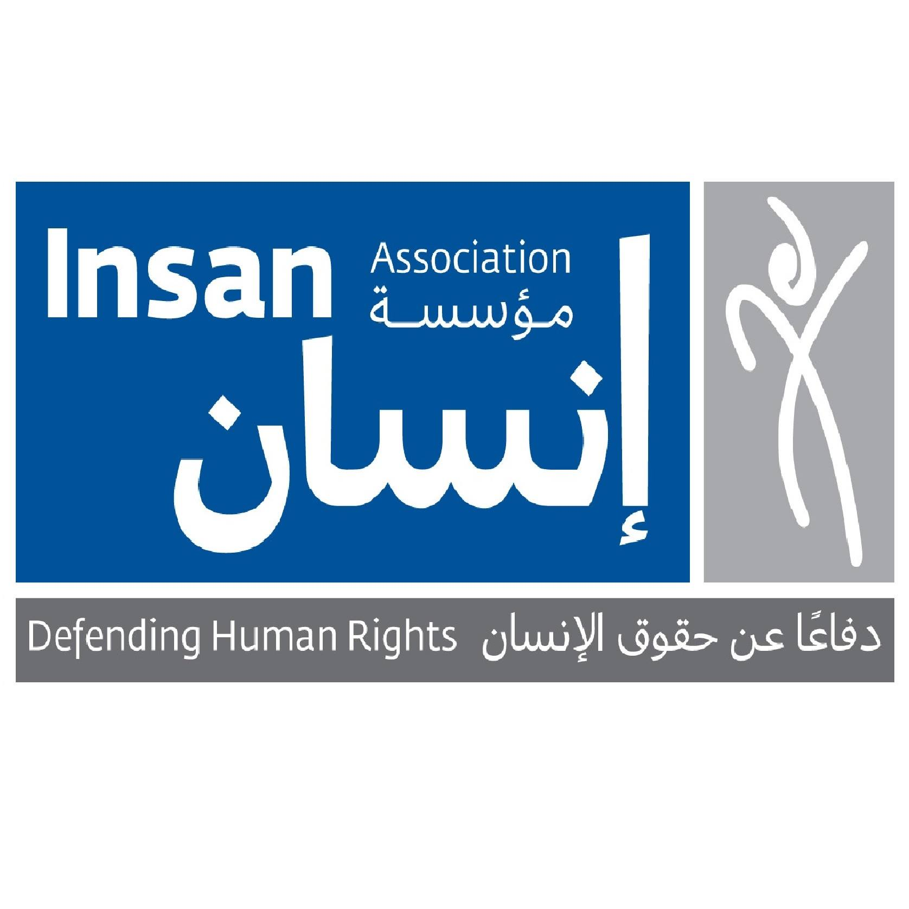

Introduction:

Migrant children in Lebanon can be divided into two categories; children of migrant workers (mainly whose parents are primarily from Sri Lanka, the Philippines, Nepal, Bangladesh, and Ethiopia) and children of refugees (most notably children of Syrian and Iraqi Refugees). What characterizes the former category however is that while children of refugees, may or may not be born in Lebanon, all children of migrant workers (category 3 and 4) are born in the country. This is because strict residency measures that apply exclusively to category three and four migrant workers prohibit them from brining in any dependents (spouses or children) to Lebanon as they migrate to work. What happens in practice however is that migrant workers from the above mentioned categories start families in Lebanon and have children in the country. There are no accurate statistics on the number of children of migrant workers in Lebanon, however, unofficial estimates put the number at around 10,000 to 15,000 children. Despite being born in Lebanon, those children are subjected to multiple human rights violation and are awarded very few rights compared to their Lebanese and Syrian counterparts and suffer from official and societal discrimination.

Lebanon signed the Convention on the Rights of the Child on January 26, 1990 and ratified it on 14th of May 1991. To date, however, the country has not ratified the Convention on Migrant Workers and Members of their Families. Despite the obvious limitations of failing recognize the rights of migrant workers under this convention, the country is bound by a number of other international conventions that enshrines similar rights to all individuals within the boundaries of the nation-state. Those conventions include the International Covenant on Civil and Political Rights, the International Convention Against Torture and Other Cruel, Inhuman or Degrading Treatment or Punishment, The International Convention on the Elimination of All Forms of Racial Discrimination, The International Covenant on Economic, Social and Cultural Rights and the Convention on the Elimination of all forms of Discrimination against women.

The following report focuses on exploring the conditions of those children using the above mentioned tools. It highlights the major human rights breaches those children face including breaches to their rights to residency, in particular through the recent policy of expulsion, the difficulty in obtaining legal status, and obstacles faced in accessing equality in education. The overall aim of this report is to provide the Committee on the rights of the Child and the Committee on Migrant Workers with a detailed picture of the most pertinent human rights violations that befall on those children and to offer a way forward by developing concrete recommendations that the committee may want to use in addressing the Lebanese state.

The Situation of Children of Migrant Worker in Lebanon:

Cases of Expulsion:
Recruiting Women Migrant Domestic Workers from various Afro-Asian Countries to Lebanon started as early as 1978. As of 1993 this trend however intensified to a large scale social phenomenon. Today it is estimated there are around 250 000 Migrant Domestic Workers whose overwhelming majority are women. Aside from the well known consequences of the feminization of migration, having a large number of marriageable age women come to Lebanon and stay for long periods of time, in some cases for periods exceeding 20 years, resulted that many of those women started families and had children in the country.

Today it is estimated that there are around 10,000 to 15,000 children of Migrant Workers in Lebanon, the eldest of which are in their late teenage years. Despite being prohibited from brining in any dependents into the country, migrant workers whose children are born in Lebanon could previously sponsor the residence of their children up to three years of age. After the age of three, children would obtain a yearly residence permit based on their school enrollment.

As of 2014, and pursuant to an unpublished General Security directive, General Security started a process of mass expulsion of those children and in some cases their parents. Families were given extremely short notices to leave the country, in some cases as short as 24 hours. General Security refused to officially comment on the reasons behind this decision, but migrant workers reported being told “you are here to work and not to have children”. In 2015, and following an extensive campaign by Insan Association that resulted in mounting domestic and international pressure, General Security temporarily suspended the expulsion of migrant workers and their children. At the time, the organization was told by General Security that the policy has been canceled. For more than 6 months Insan did not receive any new cases of expulsion and many of those who had been ordered to leave were granted renewals.

However, as of August 2015, this policy of expulsion has been reactivated. This time however, instead of basing the expulsion on the grounds of having a family in Lebanon, General Security is using the pretext of not residing with the sponsor as the basis of expulsion. This is despite that there is no legal requirement that a Migrant Domestic Worker must reside with her employer. In parallel to cases of expulsion, we have witnessed a delay in processing the applications of those migrant workers who have children in Lebanon, sometimes for over than 6 months (for the processing of a yearly residence permit). We suspect that this delay in processing is part of the policy of gradual expulsion of these workers and their children, one that General Security hopes will go unnoticed by human rights organizations and the media.

Another dangerous and recent development concerns the right to appeal decisions of expulsions among other decisions, previously General Security would accept “a request for reconsideration” or “appeal” request submitted by Migrant Workers. Insan Association has previously raised multiple concerns over the impartiality and justice of an appeal process that is made to the same entity that has taken the decision of expulsion and questioned whether General Security is the “competent authority” to decide in such appeals. Yet, in a negative turn of events, as of recently General Security would not accept any appeal submitted by a Migrant Worker in any case of expulsion. This means that migrant workers and their children who are to be expelled have no means to appeal this decision and submit reasons against this expulsion. This development constitutes a clear violation of the rights underlined by the Convention on Migrant Workers and Member of their Families that states that:
“Except where a final decision is pronounced by a judicial authority, the person concerned shall have the right to submit the reason he or she should not be expelled and to have his or her case reviewed by the competent authority, unless compelling reasons of national security require otherwise. Pending such review, the person concerned shall have the right to seek a stay of the decision of expulsion” (Article 22, CMW).

This obligation on states to allow migrant workers to submit reasons against their expulsion was also been underlined by the International Covenant on Civil and Political Rights, to which Lebanon is a state party, which further states:
“An alien lawfully residing in the territory of a State Party to the present Covenant may be expelled therefrom only in pursuance of a decision reached in accordance with law and shall, except where compelling reasons of national security otherwise require, be allowed to submit the reasons against his expulsion and to have his case reviewed by, and be represented for the purpose before, the competent authority or a person or persons especially delineated by the competent authority”.
Expelling migrant children who are born and raised in Lebanon, regardless of the pretext, constitutes a clear violation to the rights of their child and the rights of their parents. One of the principal right violated in the process is the right of migrant workers to family life. This right was clearly delineated by the Universal Declaration of Human Rights, that Lebanon abides to respect in its national constitution, and further detailed by a number of International Conventions that Lebanon has ratified, including the International Covenant on Economic, Social and Cultural Rights (ICESCR):
“the widest possible protection and assistance should be accorded to family, which is the natural and fundamental group unit of the society, particularly for its establishment and while it is responsible for the care and education of dependent children”

In addition to their great impact on the livelihoods of migrant workers, decisions of expulsions deeply affect children. We have seen cases where children are being returned to their country of origin accompanied by one parent while the other parent decides to stay behind, in order to support the family financially. In other cases, children are ordered to leave Lebanon unaccompanied while their parents’ visas are being renewed. Up to this date, we have not heard of any case where a child has returned unaccompanied while his/ her parents stayed behind, although this might very well be the case. Despite the devastating economic repercussions, when children are denied residency renewals parents choose to return with their child as returning their children alone to their country of origin will jeopardize their safety and put them at risk from various rights violations.
In an interview that was conducted with Karen, a Migrant Domestic Worker whose daughter was refused residency renewal, she told us: “I am very scared ... if the General Security will not accept our appeal I will have no choice but to return with my daughter to the Philippines. This will deeply affect us. We will have no income, no home, no family, nothing. But I have no choice... I can’t send her alone to the Philippines”.
By returning children alone the Lebanese state is compromising their safety and wellbeing and overlooking its obligation under the CRC to ensure the best interest of the child.

Poverty and the lack of economic opportunities at the country of origin eventually force many migrant workers to make tough choices such as migrating again to find work and leaving their child behind or having the child work at a very young age. In one case, a mother who returned home with her child after he was refused renewal of his residence permit was forced to return to Lebanon to find work after the family’s financial situation deteriorated significantly. The child was left in the care of his relatives in his country of origin while both his parents worked in Lebanon. This has had a devastating effect on the child who had to suffer from yet another separation after he had been separated from his father, friends and the country he grew up in.

The Convention on the Rights of the Child (CRC) that Lebanon ratified in 1991 guarantees certain basic rights to all children without any discrimination such as race, color, sex, religion, ethnic or social origin. Article 3 of the CRC maintains that the best interest of the child should be at the heart of any action affecting children:
“All actions concerning children, whether undertaken by public or private social welfare institutions, courts of law, administrative authorities or legislative bodies, the best interest of the child shall be a primary consideration”.

The Convention further specifies that children ought not to be separated from their parents unless this separation is deemed in the best interest of the child:
“State parties shall ensure that a child shall not be separated from his/ her parents against their will except when competent authorities subject to judicial review determine, in accordance with applicable law and procedures, that such separation is necessary for the best interest of the child”.

Furthermore, in all matters pertaining to the child his or her views must be heard:

“State parties should assure to the child who is capable of forming his or her own views the right to express those views freely in all matters affecting the child, the views of the child being given due weight in accordance with the age and maturity of the child”.

The separation and return of children of migrants under the current directive undermines the best interest of the child in a plethora of ways. Children that are being ordered to return to their country of origin were in all cases born and raised in Lebanon. They were all enrolled in Lebanese schools. Very few of them have ever visited their country of origin or maintained ties with family members overseas. In most cases those children could not even speak the language of their country of origin. Any attempt to return children to their country of origin will uproot them from familiarity. Child returnees have difficulty adapting to their new environment. Their right to education- another universally acknowledged right- is being jeopardized as a result of difference in curriculum and difference in the language of instruction. In the case where children are returned unaccompanied, the absence of an adult caregiver can result in the child falling victim to child labor, or even trafficking and exploitation. Finally, families are broken apart when children return unaccompanied or when a child is forced to return with one parent while the other parent stays behind.

Insan has conducted a number of interviews with children who were affected by this decision. All children interviewed expressed a desire to stay in Lebanon “I love Lebanon, I have friends here, my whole life is here. We didn’t do anything wrong I don’t understand why we need to go back to Sri Lanka”. It is evident from these interviews that in all these cases the views of children were not taken into consideration when the General Security made the determination to deny their residency renewal.

Insan has also been in touch with a number of returnees; all of whom seem to be having difficulties adjusting to their new environment. A 16-year boy from Sri Lanka who returned home with his mother is facing many difficulties. The boy told us “in Lebanon I used to have my own room, I was happy, in Colombo I have to sleep in the same room as my mother and grandmother”. The boy is currently living with his mother and grandmother in Colombo. He is also suffering from difficulties at school because of the difference in the curriculum and the language of instruction. His father laments “he calls me every day and asks me to arrange his return back to Lebanon... but there is nothing I can do”.

Recent measures to deny residency renewal for children of migrant workers goes against the two main principles of ensuring the best interest of the child and taking the child’s views into consideration in any decisions affecting him or her. By expelling children of migrant workers, General Security is taking the decision to separate children from their parents when such separation is clearly deemed contrary to the best interest of the child. General Security is also uprooting children from an environment where they were born and raised without taking their views into consideration. By doing so the Lebanese state is contravening its international obligations.

In addition to those recent more developments, migrant workers and their children have traditionally faced obstacles in registering their children and accessing education that lingers up to this date.

Birth Registration:

The right to birth registration and a nationality is one of the principal rights guaranteed by the Convention on the Rights of the Child (CRC). According to the CRC every child shall be registered immediately after birth and has the right to a name and nationality. Yet, children of migrant workers have a special difficulty in the enjoyment of this right. In 2014, Insan surveyed 3 groups of children; children of Lebanese nationals, children of undocumented migrants and children of documented migrants. The study found that migrants are at a disadvantage when it comes to the registration of their children; while all Lebanese parents (100%) reported registering the birth of their children, 10% of documented migrants and 63% of undocumented migrants did not register the birth of their child.
Lebanese laws require the birth of a child to be registered within one year of the actual date of birth. Failure to do so results in the child being considered undocumented. Many migrant workers have difficulty covering the costs that are incurred by giving birth. As a financial guarantee, hospitals have developed a customary practice of withholding the birth certificate from parents who do not settle their medical fees. In the absence of a birth certificate parents are unable to register their children and thus children become automatically undocumented.
The process of birth registration is even more complicated for undocumented migrants as obtaining a birth certificate from the hospital is no guarantee that the child will be successfully registered. Even when undocumented migrants are able to obtain a birth certificate, mukhtars (a local public official tasked with birth registration) might still refuse to register the child on the basis of the parents’ legal situation. Some mukhtars categorically refuse to register children of undocumented migrants while others accept to do so in exchange of a substantial bribe.
Unregistered children face the constant fear of arrest and detention. This fear of arrest and detention is something unique to migrant families. When we asked children who are engaged in child labor “What risks do children face at work” both undocumented migrants (28.7%) and documented migrants (69.2%) cited the fear of arrest or harassment by the police as the number one risk that children face. None of the Lebanese parents (0%) reported a similar concern. The fear of police harassment or arrest also directly affects the quality of life for children of migrants. Migrant parents were asked to list the places where their children play; a large percentage of children (30% of documented migrants, and 13.3% of undocumented migrants) stated that their children do not play, while the percentage of Lebanese parents who stated that their children do not play was 3.3%. Fears of arrest, harassment and detention deprive migrant children of their childhood. Migrant children grow up in isolation, confined to their house for fear of being arrested and deported. Migrant parents often dissuaded their undocumented children from leaving the house for the fear of getting arrested or detained.
As a result of the lack of birth registration and residency documents, children have difficulties accessing vital social services such as education and health care. Unregistered children are in many cases unable to attend school for the lack of the necessary legal documentation. In the absence of other viable alternatives children of undocumented migrants are then pushed to work at a young age, often in the informal sector, which makes them an easy prey for exploitation and trafficking. This is despite that the International Covenant on Economic, Social, and Cultural Rights that Lebanon has ratified clearly sets out the right of every child, including migrant children who are in an irregular situation, to education, adequate food, and health on the same basis as citizen children.
Being unregistered greatly inhibits a child’s ability to enjoy his or her full rights and could lead to various protection risks and rights violation. In line with Lebanon’s international commitments such as the CRC and the International Covenant on Social and Economic Rights, birth registration ought not to be contingent on the parents’ national origin or legal status. Furthermore, children of migrants including migrants in irregular situation ought to have the right to register their children. Access to social benefits should also be made available to those children without discrimination.
Access to Education:

Amidst ambivalent national legislation the right to equality in education for children of migrant workers remains highly contested.

Article 10 of the Chapter entitled “The Lebanese, their rights and their Duties” of the Lebanese Constitution recognizes the right of Lebanese children to education:
“Education shall be free insofar as it is not contrary to public order and morals and does not affect the dignity of any of the religions or sects. There shall be no violation of the right of religious communities to have their own schools provided they follow the general rules issued by the state regulating public instruction”

While the preamble of the constitution clearly states that Lebanon abides by the Universal Declaration of Human Rights, including Article 10 of the UDHR:
“Everyone has the right to education. Education shall be free, at least in the elementary and fundamental stages. Elementary education shall be compulsory. Technical and professional education shall be made generally available and higher education shall be equally accessible to all on the basis of merit”

This is despite that both the International Covenant on Economic, Social, and Cultural Rights and the Convention on the Rights of the Child, to which Lebanon is a state party, “recognize the right of every child to education” (ICESCR article 13 and CRC article 28). Article 13 of the ICESR also states that:
“with a view to achieving the full realization of this right:
(a) Primary education shall be compulsory and available free to all;
(b) Secondary education in its different forms, including technical and vocational secondary education; shall be made generally available and accessible to all by every appropriate means, and in particular by the progressive introduction of free education”. The same clause is also repeated in Article 28 of the CRC. “

Despite Lebanon’s commitment under its constitution and under international law to ensuring the rights of all children to education, a number of national legislations have failed to guarantee this right. Law number 686 of 1998 states that “education is free of charge and compulsory [...] and is the right to every Lebanese citizens of school age”. Law 686 makes no mention of the right of non-Lebanese children to education and whether education is also free and compulsory for this group. Law No. 150 of 2011 on free and compulsory education in basic education also reaffirms that basic education is the right of Lebanese nationals only; “education is compulsory at the basic level and is freely available in public school. [Education] is the right of every Lebanese of school age”.
As a result of ambivalent and disharmonized national legislation the Ministry of Education has issued a number of decisions that have, at times, compromised the right of children of migrant workers to education.
In the school year 2014-2015 as a result of increasing pressure on the educational sector resulting from the large influx of Syrian refugees, the Ministry of Education has taken a series of decisions tightening the conditions of enrollment of non-Lebanese students. The first decision came on the 5th of August 2014 and limited registration to public schools for the school year 2014-2015 to Lebanese students only. Foreign students were completely denied the right to register until another decision came out on the 17th of September 2014 establishing stringent conditions on the enrollment of non Lebanese students in the elementary cycle only, while enrolment in secondary cycles was still not permitted. In order to register, students had to satisfy one of the following conditions: be enrolled at Lebanese schools for more than three years (this condition was implemented to exclude Syrian refugees who came to Lebanon to flee the war), returning students born to a Lebanese mother, unregistered Lebanese nationals, non- Lebanese students whose parents possess a valid residency permit issued by the General Security, Palestinian students living in Lebanon for more than three years and who do not live in the vicinity of an UNRWA school.
On the 17th of October the Ministry issued yet another decision, this new decision opened registration for foreign students only in the elementary cycle with priority being given to returning students or siblings of existing students. A condition was set that their ratio ought not to exceed 50% of the total classroom and does not engender new costs incurred by the school. The decision also announced that the official registration period will end on 01/11/2014, which gave students less than 2 weeks to register.
On November the 15th, two weeks after the official registration period ended, the Ministry of Education announced that it will exceptionally accept public schools’ request to have more than 50% of its total capacity in foreign students as long as this does not incur extra costs on the school.
The Ministry of Education also required public schools to impose that parents of non-Lebanese children present valid residence permits as a condition for admission. In practice however, public schools are not only asking for parents’ residence permits but are also inspecting children’s residency documents. Using education as a means to control migration goes against the spirit and text of the CRC and ICESCR which guarantees the right of all children, including the rights of those who are in irregular situations, to education. The Committee on the Convention on the Rights of the Child “has affirmed that states’ objectives and policies concerning migration control should not deny children their human rights, even if they have breached migration law or lack a particular document” (CRC Committee, 2005).
It is estimated that in the school year 2014-2015 more than 50% of children of migrant workers were denied school enrollment as a result of those decisions. In the school year 2015-2016 all restrictions on the entry of children of migrant workers into public school were lifted, the condition to present valid residence permits for both the children and parents was also lifted. However, in the absence of the harmonization of the international instruments that Lebanon has ratified and national legislation on equal rights to education the rights of children of migrant workers could still be compromised at any minute by Ministerial resolutions. This is why amending current legislation on education is of the utmost importance. Because still, decision of accepting foreign children in public school is very much arbitrary and is done on a case by case basis with no clear guidelines.
A study by Insan Association (2014) preceding the Ministry of Education’s decisions, which examined the general prevalence of school absence and drop out found that 56.7% of children of documented migrants and 55.2% of children of undocumented migrants did not attend school. In contrast all Lebanese children (100%) reported attending school. This number suggests that in addition to official discrimination on the level of policies and laws a number of other factors hinders the ability of children of migrant workers to attend school. Those factors include poverty and the lack of ID documents. The burden of (partial) tuition fees, textbooks, stationary, uniform and transportation are something that many migrant families cannot afford, this cost is weight in comparison to the potential financial gain that child labor can bring to the family. As a result, children are forced to drop out of school and seek employment from a very young age. Indeed, we have found elevated percentage of child labor among our population of migrant families; whilst only 3.3% of our Lebanese children sample were engaged in child labor, 50% of documented migrants and 23.3% of undocumented migrants contributed to their families’ income. Furthermore, it is estimated that around 8% of children enrolled in the Insan School have dropped out of their previous school for financial reasons despite the school being tuition free. These factors coupled with the non-registration of children that is a common problem among migrants explains the lower school attendance rate among migrants compared to Lebanese children.
Recommendations:
On Expulsion and Non-renewal of Residence Permits:
- General Security must immediately stop the expulsion of migrant workers and their children on the basis of having children or not residing with their employers. Furthermore, children and migrant workers who were wrongfully affected by those decisions must be compensated and granted residency renewal. This should include migrant workers and children who chose to return to their country of origin and those who chose to remain in the country and subsequently became undocumented.
- In cases of expulsion, General Security must notify the migrant worker and his/her dependents in writing of the grounds of expulsion. Further, a sufficient period of time must be given for the decision to take effect, enabling the migrant worker to appeal the decision or settle any other unresolved issues, such as unpaid wages etc..
- General Security must resume accepting appeals from migrant workers who wish to have their cases reconsidered. A clear and transparent mechanism for settling those appeals should be established. There should be an independent body to study and make decisions on the appeals.
- General Security must revoke its policy on banning family reunification for category three and four migrant workers. Instead a minimum support requirement could be established for migrant workers of all categories.
On Birth Registration:
- The Lebanese state must ensure that migrant parents have the right and means to register their children regardless of their immigration status or their national origin. In order to do so the Lebanese state must ensure that mukhtars are obliged to register the birth of all children that are presented to their offices. In lieu of requesting and inspecting parent’s residency documents, mukhtars should be instructed to request an official identification from the child’s parents in the form of a passport, or a national ID or any other types of official documents.
- The Lebanese state should also ensure that registered and unregistered children have equal access to vital services including health care and education. Access to social services should not be used for immigration control or as a means to punish undocumented or unregistered children. The Lebanese state must take effective measures to ensure that all children are able to enroll in both public and private schools upon presenting an identification document such as a national passport or birth certificate. Similar procedures for admitting new patients should be followed by public hospitals.
On Equal Access to Education:
- The Lebanese state must ensure that all children on the Lebanese territory ought to have equal rights to education. In this regard, any decision or law that discriminates between Lebanese and non-Lebanese children should be revoked and amended. Furthermore, the right of undocumented children to education should be guaranteed. Practices requiring valid residency permits for either the children, parents or both as a condition for school enrollment should also be abolished.
- The Lebanese parliament must take appropriate measure to amend the legislation in order to reflect Lebanon’s international obligations. Amendments should be targeted at Law No 686 of 1998, Law No 150 of 2011. Amendments should include abolishing any clauses that discriminate between Lebanese and non-Lebanese children in the provision of the right to education. Legislative amendments should also guarantee the right of all children, documented or undocumented, to free and compulsory education that is based on merit.
- Given the relationship between poverty, lack of documentation and migrant children’s inability to attend school, the Lebanese state must ensure that public schools are legally obliged to accept migrant children regardless of their legal status and without any discrimination.

Established in 1998 by a group of Human Rights activists, Insan Association is a Lebanese non-profit organization. Insan Association acts to protect and promote the rights of the most marginalized individuals, families and children living in Lebanon – such as refugees, migrant workers, asylum seekers and non-identities – without discrimination of any kind, such as ethnicity nationality, gender, social origins, religion and political or other affiliations.
Category three workers are workers who are employed in agriculture and the cleaning sector. Category four workers are domestic workers.
Jureidini, R., 2002 ‘Women migrant domestic workers in Lebanon’, International Migration Papers 48, ILO, Geneva.
Those prohibitions are discriminatory as they apply selectively to migrant workers from category three and four.
General Security is a Lebanese intelligence agency established in 1921. The General Security carries out diversified functions including general intelligence work, media censorship and handles all matters relating to the stay and exit of foreigners on Lebanese soil. General Security is the only agency authorized to regulate the entry and stay of foreign nationals in Lebanon.
(CRC Committee, 2005): http://www.ohchr.org/Documents/Issues/MHR/Consultation2010/3a.UNICEF_ESCR_Migrants.pdf
Those numbers were taken before the restrictions on entry into schools were applied on children of migrant workers.
Insan School is a special school for children of migrants

